BB001 Examination (Date: July.07.2011/Duration:60 minutes) -You can use your note.
Code :____________ Your Name:__________________________________
1. Complete the following cell design based on the following conditions. 10 points
1) N channel MOS in CMOS process. 2) Gate length(L)=0.8um. 3) Current per unit channel width = 30uA/um. 4) Electro migration of metal = 20uA/um. 5) Electro migration of CONTACT is 50uA/piece. 6) The cell can flow Ids of 150uA.
Complete the drawing. Free hand is OK. Write the dimensions, and the type of diffusion...
The cell you draw should have (a: -WELL ), the channel width of (b: ) um, the number of contact holes per side is (c: ) and more, and the minimum metal width is (d: ) um.
Fill the parentheses with the correct words. 4 points each
- A (a: ) is macro or functional unit that performs common operations and is used to build more complex logic blocks.
- A cell library consists of (b: ) and back end library.
- (c: ) is one of a verification whether the layout meets (d: ) are checked.
- Before starting Standard cell design, it is important to decide (e: ) which effects the cell drivability . The width of (f: ) is determined considering IR drop and electro-migration.
- Cell based method uses (g: ) cells for logic portion.
- (h: ) needs spare cells if chip layout is not re-designed from the beginning.
- Automatic placement and routing (P&R) technique is used for the layout design of large-scale LSI. The important points of layout design are a power supply design,

(i: ) and (j: ) .
- At (i), the control of the clock skew is indispensable. The clock is a signal that is basic of RTL design based LSI. Because logic gate signals are controlled by clock, if clock skew is insufficient , the violation of timing occurs which results in mal-function of LSI.
- At the step of (j) , the cell placement, routing between cells, resizing of cells and buffer insertion are done to satisfy the timing restriction considered at the logic design.

- (k: ) means the extraction of wire loads from the layout after P&R.
- Design rules are the rules that have to be respected when a given design is laid out. There are design rules for all of the components we have been introduced to: polygons, paths, transistors and contacts. Fundamentally, these design rules represent the physical limits of the (l: ) . Design rules include : (m: ) rule, (n: ) rule, (o: ) rule

-The minimum gate length of a transistor is the prime example of (m) rule.
-(n) rule is applied to avoid an unwanted short circuit between two polygons
-The (o) of a metal layer over a via or contact is a prime example of (o) rule
11. For LSI of deep submicron/nano- technology, signal integrity design/verification is needed. They include phenomena : (1) Power-supply voltage drop, (2) (p: ),
(3) electro Migration, (4) (q : )
12. Complete the following IC design flow and Layout design flow (3 points each) Select the correct word from the candidates.
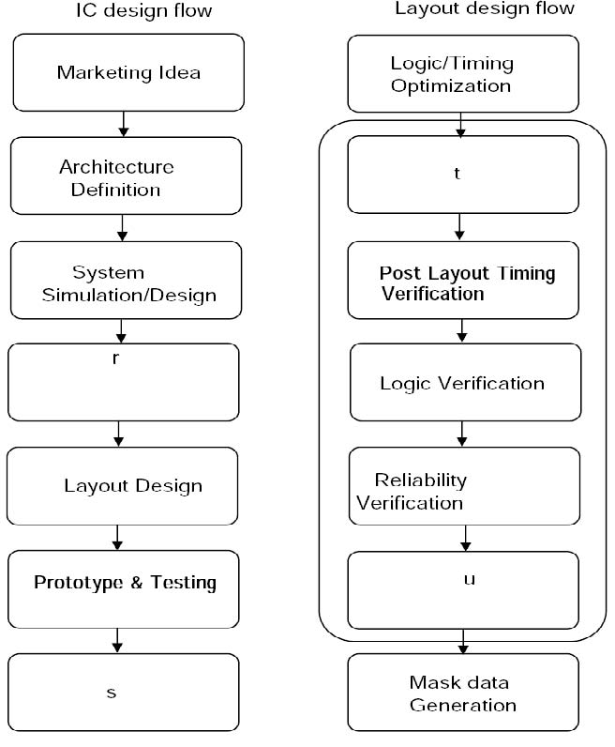Candidate list
(1) Marketing Idea (2) Mass Production (3) Post Layout Timing Verification
(4) System Simulation/Design (5) Logic /Timing Optimization (6) Circuit Simulation/Design
(7) Layout Design (P&R) (8) Prototype & Testing (9) Reliability Verification
(10) Layout Verification (11) Mask data Generation (12) Architecture definition (13) Logic Verification

rstu
13. Calculate IR drops 4 points Condition : Sheet resistance of metal is 50 milli ohm per square. Width is 2.0um.
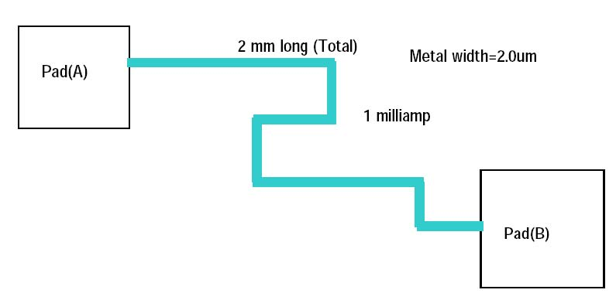Resistance of wire is given by R=ρ* L/(T*W) where, ρ is electrical resistivity, L is wire length, T is thickness and W is width Sheet resistance Rs is defined as ρ/T.
14 Transistor layout 10 points
- Draw layout of an inverter cell with circuit below:
A YB
